Diploma in Radiodiagnosis Technology (DRDT) with 10 seats approved from the Academic year 2022-2023

First Batch of DRDT joined in January 2023 with an intake of 8 students.
Students – DRDT-1st Batch:
- Ms. M. Manjula (Service Candidate)
- Ms. R. Anitha
- Ms. R. Eswari
- Mrs.G. Apoorva
- Ms. G. Padmavathi
- Ms. M. Jeffrin Rajkumar
- Ms. S.R. Jagan
- Mr. M. Naganithish

Theory & practical classes are conducted in Basic Medical Science Block for Anatomy & Physiology followed by General & Radiation physics at the Department of Radiology Physics. Clinical Radiography theory and practicalsand practical training were conducted in Department of Radiodiagnosis.
Internal examination for DRDT -1st year examination will be conducted at the Department of Radiodiagnosis as below

October 9, 2023 - Paper - I - Human Anatomy and Physiology
October 10, 2023 - Paper - II - General & Radiation Physics
October 11, 2023 - Paper - III - Physics of Diagnostic Radiology
October 12, 2023 - Paper -IV - Clinical Radiography.

As per the notification of Board of Paramedical Education, Kings Institute of Preventive Medicine & Research, Guindy

First Batch of OMC - DRDT - 1st year Examination time table for December 2023 as below (Attachment) - PDF attached

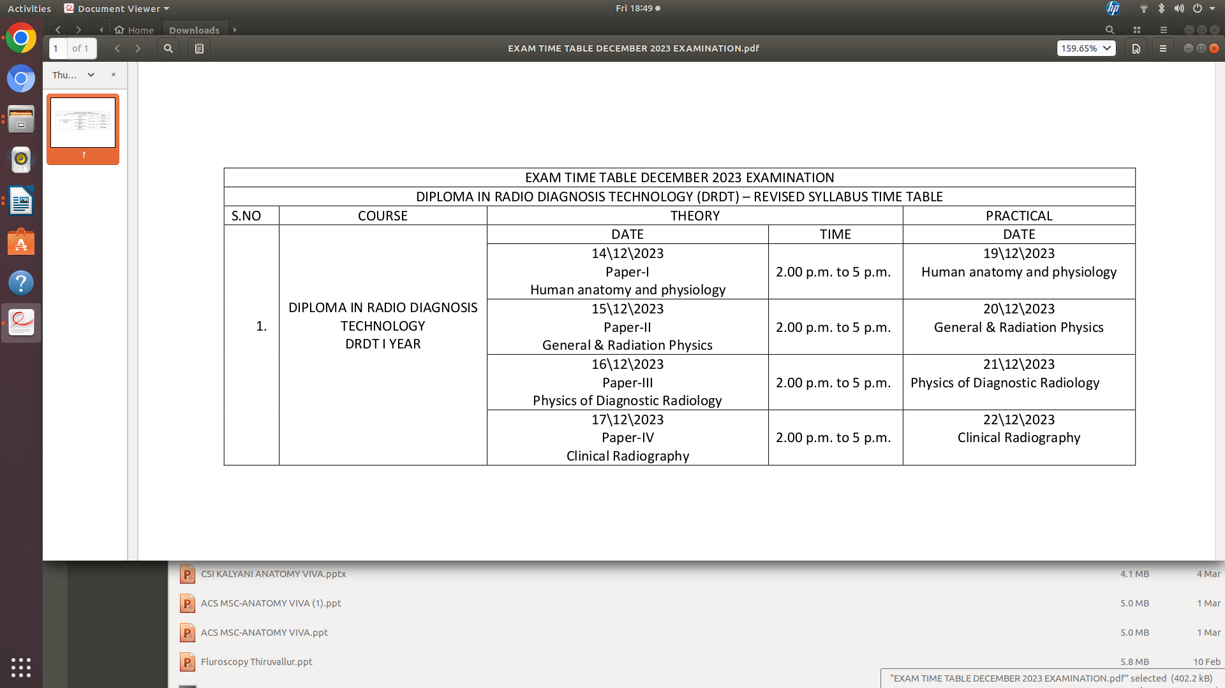
Second batch of OMC - DRDT students joined in January 2024 with an intake of 8 students.

Students – DRDT-2nd Batch

- Ms. K. Hemalatha
- Ms. T. Madhumitha
- Ms. R. Mageshwari
- Mr. H. Mohammed Hassain
- Mr. M. Rajkumar
- Mr. S. Roganth
- Mr. B.H. Shanmugam
- Ms. B. Sandiya

Theory and practical Classes are conducted at Department of Radiodiagnosis and Radiology Physics.

Internal examination for DRDT -2nd year examination will be conducted at the Department of Radiodiagnosis as below
November 5, 2024 - Paper - I - Clinical Radiography & Patient care
November 6, 2024 - Paper - II - Techniques in Imaging Modality
November 7, 2024 - Paper - III - Radiation Hazards, Control and Safety (RD)
November 8, 2024 - Paper -IV - Project

As per the notification of Board of Paramedical Education, Kings Institute of Preventive Medicine & Research, Guindy

First Batch of OMC - DRDT - 2nd Year Examination time table for January 2025 as below (Attachment) - PDF attached

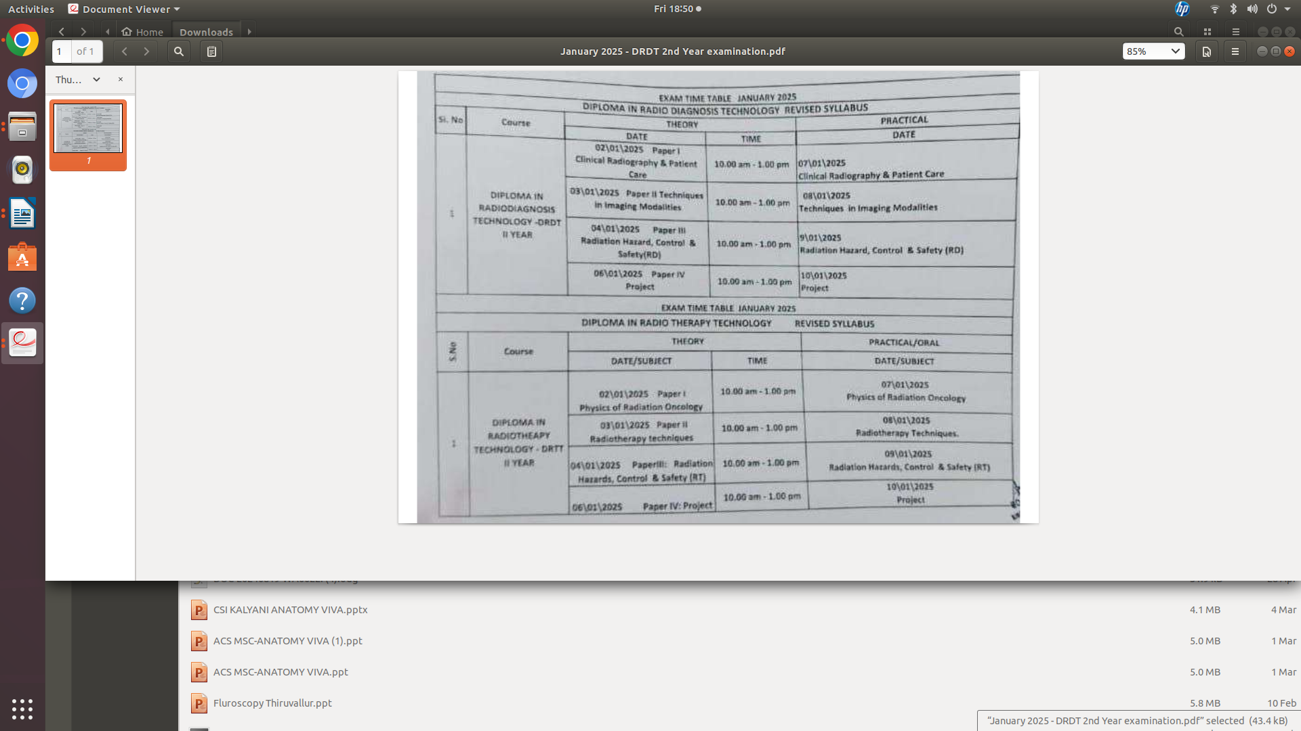

Second Batch of OMC - DRDT Exams:

Internal examination for DRDT -1st year examination will be conducted at the Department of Radiodiagnosis as below
November 11, 2024 - Paper - I - Human Anatomy and Physiology
November 12, 2023 - Paper - II - General & Radiation Physics
November 13, 2024 - Paper - III - Physics of Diagnostic Radiology
November 14, 2024 - Paper -IV - Clinical Radiography.

As per the notification of Board of Paramedical Education, Kings Institute of Preventive Medicine & Research, Guindy

Second Batch of OMC - DRDT - 1st year Examination time table for February 2025 as below (Attachment) - PDF attached

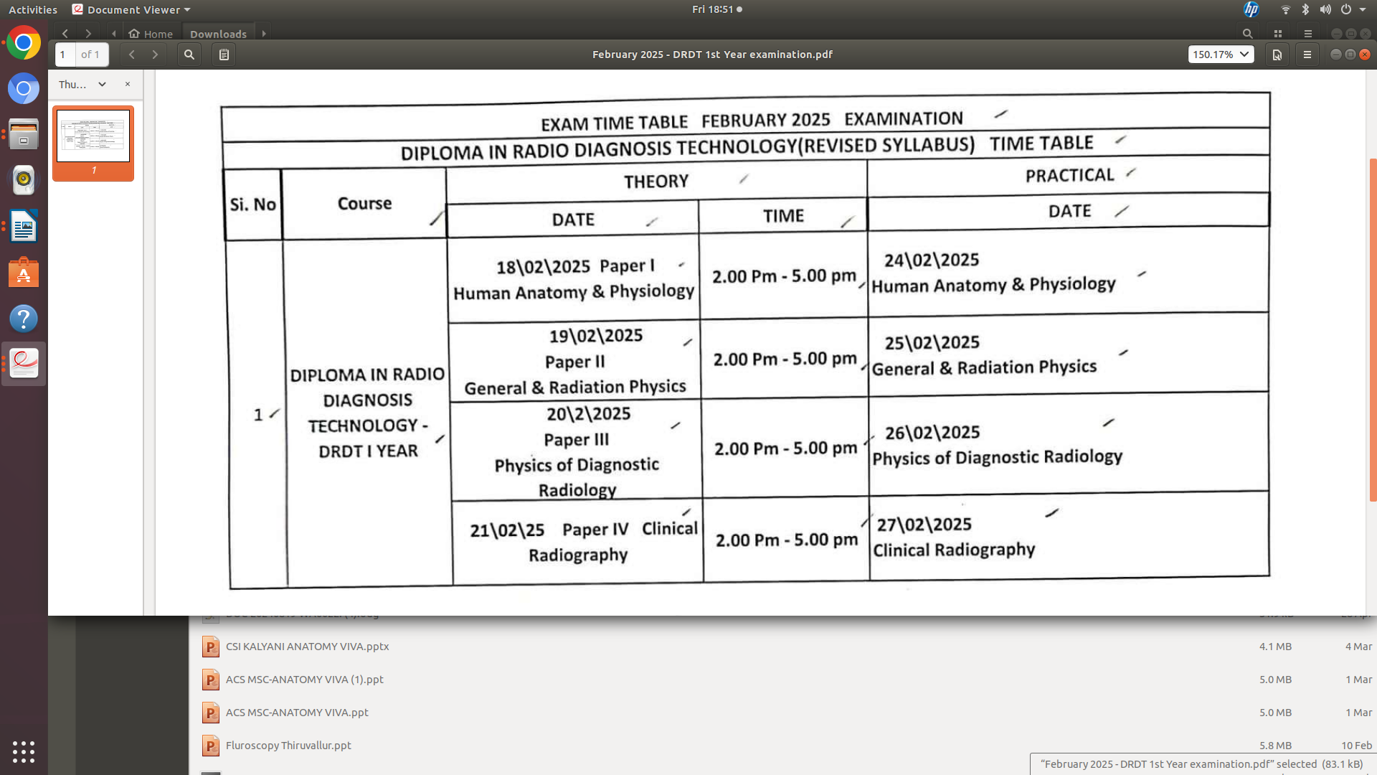

First Batch Students Completed their theory Exams by January 10, 2025 and Started their internship for a period of 3 months and completed by March 2025.

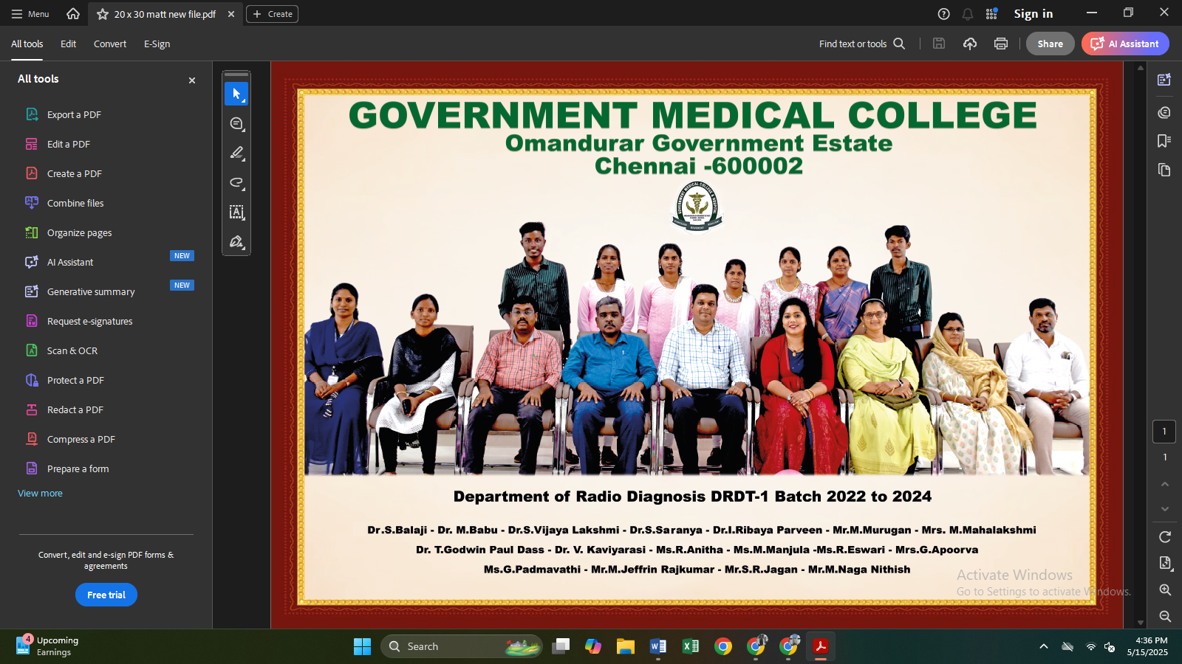

Third batch of DRDT with intake of 5 students commenced in March 2025
Classes are systematically scheduled.
Students – DRDT-3rd Batch
- Mrs. S. Saritha
- Mrs. A. Deivapriya
- Ms. M.R. Sujatha
- Ms. M. Kodiarasi
- Mr. K.S. Began

